**This Document is to show you how to upload more than 100mb on GitHub and work on the project.**

1. **Download Git. Don’t change any option during the installation except the default editor for Git if you want.**[**https://git-scm.com/downloads**](https://git-scm.com/downloads)
2. **Download Git LFS**[**https://git-lfs.com/**](https://git-lfs.com/)
3. **Download GitHub Desktop**[**https://desktop.github.com/**](https://desktop.github.com/)
4. **Clone the repository on GitHub desktop.  
   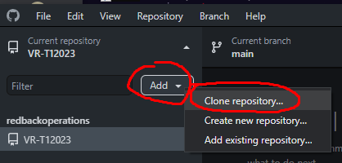**

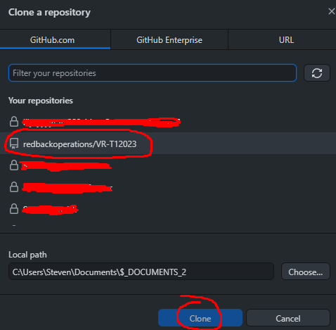

**It will ask you if you want to initialize GIT LFS. You need to Initialize it and accept it if you want all the files to be there and working.**

**Now you can Open the Explorer:**

1. **Now you should be able to work on the repository and make changes. You don’t have to read the following steps except if you want to know how Git LFS work.**
2. **Right click on the Explorer file (where the GitHub repo is)  
   Graphical user interface

   Description automatically generated**
3. **Click on Git Bash Here  
   Graphical user interface

   Description automatically generated with low confidence**
4. **Mingw64 will open and write the command: git lfs install**

**This will initialize Git LFS**

1. **Open the Unity Project and make sure the project is “Force Text” (Usually this is the default option)**

1. **Now we want Git LFS to track files that can be over 100mb. For now, we use .psd (If .gitattributes already exist. You do not have to do this part Go to step 13.)  
   Text

   Description automatically generated**
2. **A new file will be created that tracks the specified files.  
   Graphical user interface, text, application

   Description automatically generated**
3. **Now when you try to commit a new change to the project and a file is over 100mb. Check its file extension.**Text

   Description automatically generated**Open .gitattribrutes and write this code**
4. **Now Commit .gitattributes first and then commit the change that was more than 100mb. If you try to commit the change that include 100mb. It will not accept it. You need to commit the change of .gitattributes to accept your file that is more than 100mb**
5. **This code will show all the files that have been track by Git LFS  
     
   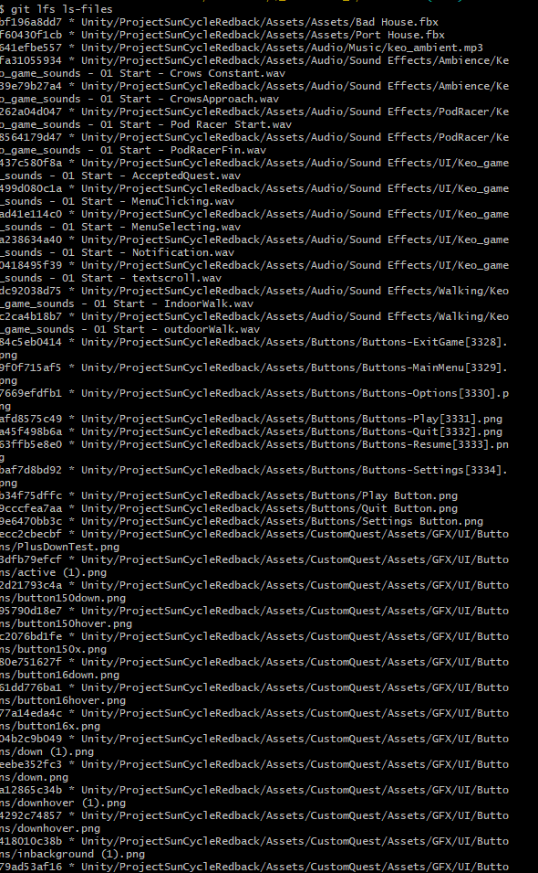**

**Now you should be able to upload more than 100mb**